Subject line (general): Join me to help inspire young people!

Subject line (colleagues): Our opportunity to raise the profile of <INSERT INDUSTRY>

Kia ora,
I’ve recently become involved in an exciting new programme called Inspiring the Future that has been created to broaden young people’s horizons, and help challenge stereotypes that can limit their potential.
Inspiring the Future events are hosted by schools and provide an opportunity for rangatahi to learn about different jobs and why people love doing them, as well as how those people got started in their careers.
There are in-person and online event options so that people have the opportunity to take part no matter where they live.
I think you would be a great Role Model.
Inspiring the Future needs people from all sorts of jobs to share their stories, and open children’s eyes to more of the possibilities.
In addition it’s a great chance to showcase your job and industry to the community.
You can sign-up to be a role model at inspiringthefuture.org.nz

Why Inspiring the Future is needed
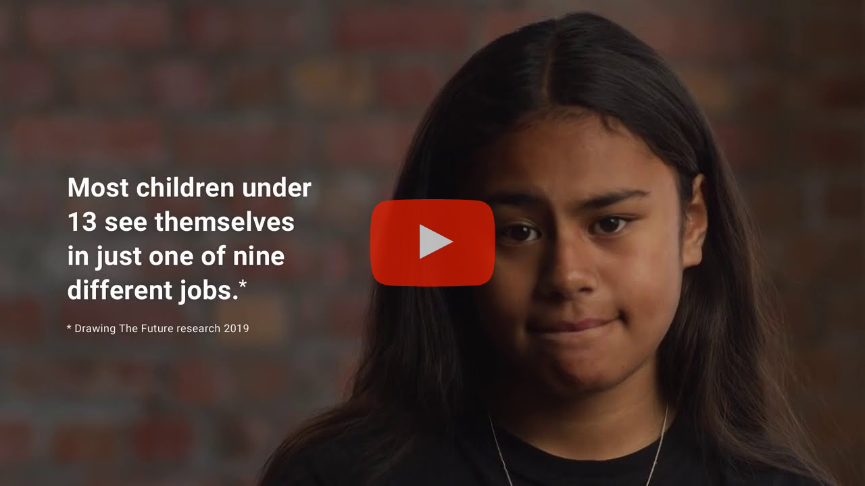
Watch the video
Drawing the Future is a national survey commissioned by the Tertiary Education Commission in October 2019. Students aged 7 to 13 were asked to draw a job they wanted to do when they grew up.
The results found that more than half of young people aged 7 to 13 see themselves in one of just nine most popular jobs, as well as patterns of unconscious bias about gender, ethnicity and socio-economic status.

How it works
When you sign up to be an Inspiring the Future role model, you’ll be asked to complete an online profile and a criminal record check form.
Your profile will be visible to schools on the website after the criminal record check. Teachers can then read your profile and invite you to participate in Inspiring the Future events.
Signing up as a role model doesn’t mean you have to participate in events. You can accept or decline as many event invitations as you wish based on your availability.
This video will give you an idea of what an in-person event is like.
And you get support and resources every step of the way, so it’s easy and fun!

Your time commitment
In-person Inspiring the Future events last up to 4-5 hours, and online events last 1-2 hours plus a half hour pre-meet.

Let me know if you have any questions or want to be involved! You can also find out more and sign-up at inspiringthefuture.org.nz

Ngā mihi

