**Te Tātauira Pātai e 20**

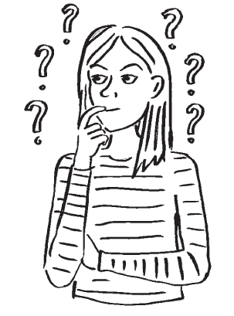

I tēnei o ngā tūmahi, me whakaaro koe mō ngā mahi a ngā tauira mā te tuku pātai.

Kia uaua ai ō mahi raparapa, me pātai noa i ngā pātai ka whakautua ki te “āe”, “kāo”, “i ētahi wā”, i te “tērā pea” rānei.

Whakaarohia ngā pātai hei āwhina i a koe ki te tohu i tā rātou mahi.

Mēnā kāre ō pito whakaaro, tirohia ngā pātai kei raro nei.

Ina tīmata koe i te tūmahi, whakamahia te papa rārangi i tērā taha ki te whai i ngā pātai me ngā whakautu.



Mahi ai koe ki ngā mahi hanganga?

He kaimahi ā-rehe koe?

Mahi ai koe ki tētahi mea, ākene pea kei tō mātou kura?

He rangatira tōu?

He rangatira koe?

Mahi ai koe me ngā tāne, wāhine hoki?

Mahi ai koe i runga waka whenua?

Me mahi koe i ngā rā whakatā?

Mahi ai koe me ētahi mea, ā, i muri iho ka pā te ringa a te hunga tangata ki aua mea rā?

He kaipapatono rorohiko koe?

**Tauira pātai**

Mahi ai koe me ngā kararehe?

He kaha tō tuhi i tō mahi?

Mahi ai koe me ngā mīhini nui i tō mahi?

Mahi ai koe i roto i ngā kura?

Waihanga mea ai koe me ō ringa?

Mahi ai koe me te hunga tamariki?

Mahi ai koe ki te wāhi kotahi i ia rā?

He mahi toi anō koe ki tō mahi?

Mau ai koe i ngā kākahu e mau nā koe ināianei i a koe e mahi ana?

He pai ki tō whānau tō mahi?

Kua mahia e koe he mahi ihupuku?

Me haere koe ki te whare wānanga mō tō mahi?

**Te Tātauira Pātai e 20**

Tuhia ki roto i te tūtohi i raro ngā pātai kua tukuna. Whakamahia te “A” mō te “Āe”, te “K” mō te “Kāo”, te “EW” mō te “Ētahi Wā” me te “TP” mō te “Tērā Pea” i raro iho i te nama a ia o ngā tauira mahi.

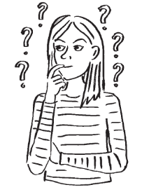

20 questions V2 Māori Doc

|  |  |  |  |  |  |  |  |  |  |  |  |
| --- | --- | --- | --- | --- | --- | --- | --- | --- | --- | --- | --- |
| **Questions** | | **Whakautu (A, K, EW, TP)** | | | | | | | | | |
| **Nama Tauira Mahi** | | | | | | | | | |
| **1** | **2** | **3** | **4** | **5** | **6** | **7** | **8** | **9** | **10** |
| **1** |  |  |  |  |  |  |  |  |  |  |  |
| **2** |  |  |  |  |  |  |  |  |  |  |  |
| **3** |  |  |  |  |  |  |  |  |  |  |  |
| **4** |  |  |  |  |  |  |  |  |  |  |  |
| **5** |  |  |  |  |  |  |  |  |  |  |  |
| **6** |  |  |  |  |  |  |  |  |  |  |  |
| **7** |  |  |  |  |  |  |  |  |  |  |  |
| **8** |  |  |  |  |  |  |  |  |  |  |  |
| **9** |  |  |  |  |  |  |  |  |  |  |  |
| **10** |  |  |  |  |  |  |  |  |  |  |  |
| **11** |  |  |  |  |  |  |  |  |  |  |  |
| **12** |  |  |  |  |  |  |  |  |  |  |  |
| **13** |  |  |  |  |  |  |  |  |  |  |  |
| **14** |  |  |  |  |  |  |  |  |  |  |  |
| **15** |  |  |  |  |  |  |  |  |  |  |  |
| **16** |  |  |  |  |  |  |  |  |  |  |  |
| **17** |  |  |  |  |  |  |  |  |  |  |  |
| **18** |  |  |  |  |  |  |  |  |  |  |  |
| **19** |  |  |  |  |  |  |  |  |  |  |  |
| **20** |  |  |  |  |  |  |  |  |  |  |  |