**Investigation session template and example questions**

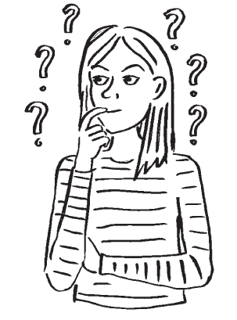

In the investigation session, you will try to guess what jobs the role models do by asking them questions.

To make it hard to guess, you can only ask questions that can be answered with “yes” or “no”, “sometimes” or “maybe”.

Try to think of questions that will help you guess their job.

If you are stuck for ideas on what to ask, take a look at the questions below.

Once you start the activity, use the table on the other side to keep track of the questions and answers.



Investigation session template and example questions V1

Do you work in construction?

Are you a tradesperson?

Do you work on anything that we might have in this school?

Do you have a boss?

Are you the boss of other people?

Do you work with a mix of men and women?

Do you work in transport?

Do you have to work weekends?

Do you work on things that people touch and use afterwards?

Do you programme computers for part of your work?

Did you need to go to university for your job?

**Example questions**

Do you work with animals?

Do you need to write much for your job?

Do you control big machines at work?

Do you work in schools?

Do you make things with your hands?

Do you work with children?

Do you work in the same place every day?

Are art and design a part of your job?

Do you wear the same kind of clothes you’re wearing now when you work?

Does your family like the work you do?

Have you done an apprenticeship?

**Investigation session template**

Write the questions that have been asked in the table below. Put “Y” for “yes”, “N” for “no”, “S” for “sometimes” and “M” for “maybe” below each role model’s number.

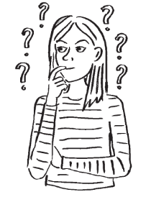

|  |  |  |  |  |  |
| --- | --- | --- | --- | --- | --- |
| **Questions** | | **Answers (Y, N, S, M)** | | | |
| **Role model number** | | | |
| **1** | **2** | **3** | **4** |
| **1** |  |  |  |  |  |
| **2** |  |  |  |  |  |
| **3** |  |  |  |  |  |
| **4** |  |  |  |  |  |
| **5** |  |  |  |  |  |
| **6** |  |  |  |  |  |
| **7** |  |  |  |  |  |
| **8** |  |  |  |  |  |
| **9** |  |  |  |  |  |
| **10** |  |  |  |  |  |
| **11** |  |  |  |  |  |
| **12** |  |  |  |  |  |
| **13** |  |  |  |  |  |
| **14** |  |  |  |  |  |
| **15** |  |  |  |  |  |
| **16** |  |  |  |  |  |
| **17** |  |  |  |  |  |
| **18** |  |  |  |  |  |
| **19** |  |  |  |  |  |
| **20** |  |  |  |  |  |